DO IT – Front End developer

Mini project 2 – Contract application for travel – HTML TABLES - LINKS

SMART d.o.o, New Frontier Group

Version: 1.0

Revision date: July 26, 2016

Table of Contents

Specification of mini project 2

Requirements for this project 3

Tasks 4

Timeline 5

Tools 6

# Specification of mini project

In this mini project your task will be create same page as shows in miniproject2.jpg.

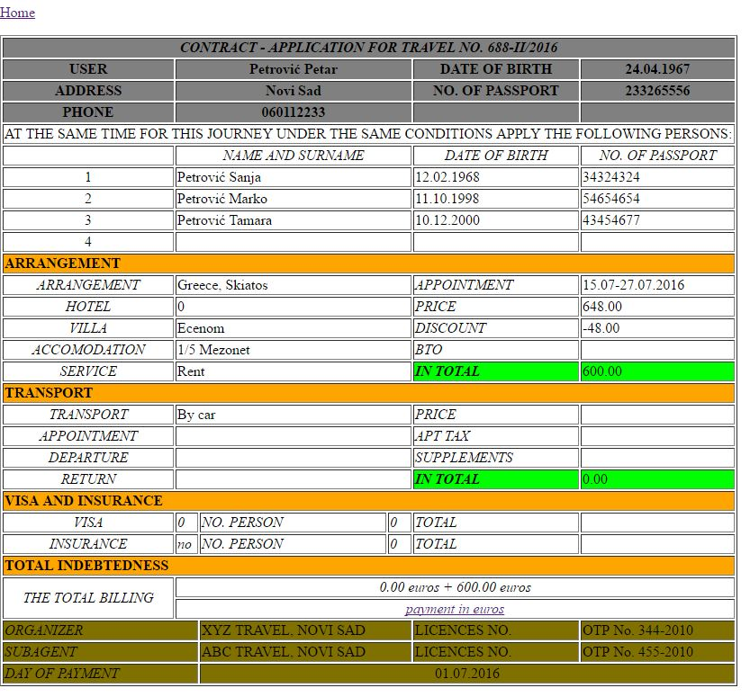

Picture 1 – miniproject2.jpg

Scope of this project is to use html basic elements to make your first web page.

You will use text file xyz.txt for every text that you need for this project and that is entered as you can see in miniproject1.jpg preview.

# Requirements for this project

Before you can start with this project you need to finished HTML fundamentals class.

**Tasks**

So your job is to do next :

1. Create new html document and call it contract.html
2. Write DOCTYPE declaration with English language.
3. Create basic structure of html document and include html,head,body tags.
4. Define meta tag with UTF-8 charset in head tag.
5. Define title element with text “MINI PROJECT 2” in head tag.
6. Use image background-10.jpg as you background image.
7. Now you need to make table with border 1.
8. In table you need to put head, body and footer.
9. In table head change color to #808080.
10. You need to put for rows in head an whole table has 6 columns, so make header as on picture and use colspan to get same view as on sample picture.
11. After that you need to put in table body 26 rows with 6 columns. You will need to use colspan and rowspan where it needs to put.
12. In text when you see italic text use em element and for bold text use strong element.
13. In rows Arrangement ,Transport, Visa and Insurance , Total Indebtedness use bacgroung color orange, and in columns with green color use #00FF00 for color.
14. In table footer you will have 3 rows and six columns. Make table like in picture and use colspan for that.
15. Set background color with #807000 in table footer.
16. Make text *payments in euros* like link. Use this link for this <http://www.nbs.rs/export/sites/default/internet/latinica/scripts/kl_srednji.html> This wil show average exchange rate in euros and link you to page of National Bank of Serbia.

**Additional tasks**

1. Copy index.html page and images folder from mini project 1 and paste it in same folder where is contract.html page.
2. Now in contract.html make link just like on picture stands, before table. Link is in paragragh in left position.
3. Name this link as Home and reference it to index.html page.

Your result should look like on picture miniproject2.jpg

Good luck!

# Timeline

You will have 4 hours to finish this job.

This timeline is for main parts of the task. Bonus parts should be implemented only if there is extra time left.

# Tools

## IDE and Source Control

You can use either Atom or Brackets tool for development during this project

ATOM - <https://atom.io/>

BRACKETS - <http://brackets.io/>